Methods
You will be simulating the evolutionary processes of drift and natural selection using Virtual Biology Lab's digital fish pond (http://virtualbiologylab.org/ModelsHTML5/PopGenFishbowl/PopGenFishbowl.html). In this simulation, digital koi fish (carp) will serve as the model organism to observe these processes in action.
In this model, there are three genotypes and phenotypes for koi:
- Homozygous recessive (rr) - fish are white all over
- Heterozygous (Rr) - fish are mottled/white with orange spots
- Homozygous dominant (RR) - fish are orange all over
You can read the Background tab from the model's homepage for review of the concepts described above.
To learn how to manipulate the parameters of the model, click on the "Tutorial" tab for instructions. Once you have finished reading the instructional pop-ups, the model will immediately begin. Right away, press "Pause" and set your parameters for the following trial.

Genetic Drift
We will first simulate genetic drift, or random change in allele frequencies, by creating a population of organisms and following it for several generations.
For the first simulation, you keep leave all parameters at their default values. Note what this means. We have a population of 200 individuals at the beginning, distributed in such a manner that the initial R allele proportion is 0.5 and the population is evenly split among males and females. The population can't go over 200 individuals (carrying capacity), and there are also default mortality (death) and brood size parameters set that should stop your population from going extinct. MIgration rate is 0, so we are dealing with a closed population. Mutation rate is 0 (alleles won't change by chance). All phenotypes have the same relative fitness (1), and no assortative mating taking place.
These conditions result in a setting where evolution (change in allele frequencies) can only occur do to chance. To see this we'll run and compare several simulations.
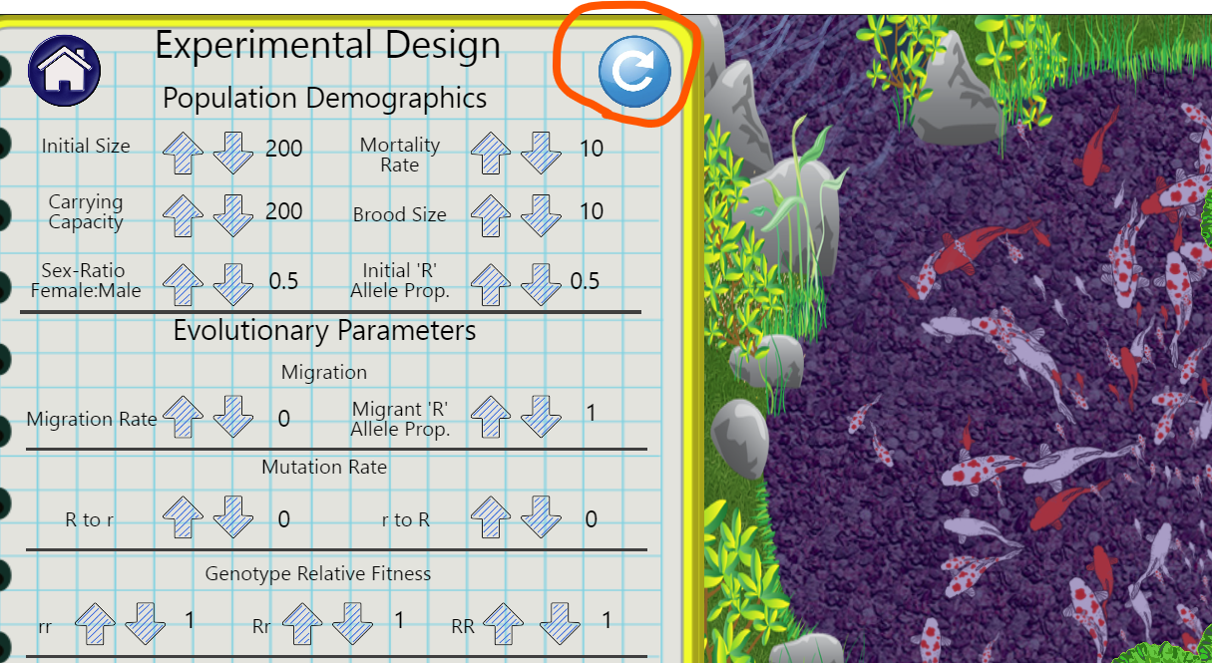
To begin a simulation, click the blue icon with the curved arrow (circled in red). The koi population you designed will begin moving around in their pond. Speed up time to the maximum (16x), then click on the "To Data" Arrow to watch what happens. Let it run for about 250 generations-- this will only take a few minutes. Then press pause and assess the composition of the pond.
1. What are the frequencies of the genotypes rr, Rr, and RR in your pond?
2. Look at the graph in the lower left labelled "Allele Proportion". It displays the proportion of the R allele in the population each generation. Is there any distinguishable pattern or trend in the proportion of alleles during this trial? If not, why do you think your graph looks the way it does? Take a screenshot of the graph and label it "Genetic Drift, Simulation 1".
Now run the model with the same parameters again for the same amount of time (click the blue curved arrow icon to restart the simulation; do not just continue running for another 250 generations).
3. What are the new genotype frequencies? Are they the same as your previous trial? Different? Why?
4. Take a screenshot of the "Allele Proportion" graph again and label it "Genetic Drift, Simulation 2".
Run the model with the same parameters again (click the blue curved arrow icon). Do this several times (you need to run at least 10 simulations total), saving the allele graph each time and labeling it appropriately.
5. How do the final graphs of allele proportion compare? Do you see any trends in allele proportion among or within the simulations?

Natural Selection
Next we'll simulate natural selection. To do this, we'll add one small twists to our previous instructions.
Return to the Design window. You will now alter the relative fitness of the genotypes. Imagine that the homozygous recessive genotype that creates the all-white phenotype also results in less healthy fish than the other genotypes. Maybe they are more likely to be eaten by predators, or maybe they are more prone to illness.
Reduce the fitness of the rr genotype to 0.0 (extreme selection!) and run the model on maximum speed.
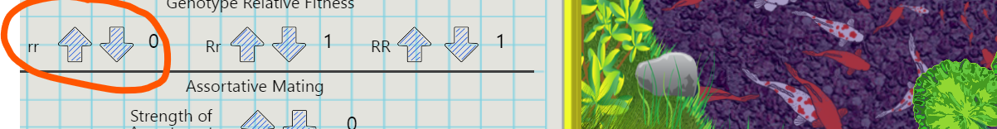
6. After ~250 generations, what are the frequencies of each genotype? Save an image showing the "Allele proportion" graph and label it "Natural Selection, Simulation 1"
7. Restart the simulation (click the blue curved arrow icon). Save and label the Allele proportion graph again.
8. Do this another 8 times (for 10 total trials).

Review Questions
9. Compare the changes in allele frequency across generations compare in the drift and selection simulations. What did you expect to happen in each? Why?
10. Why does drift have a larger impact on small populations? How could you demonstrate this in the simulation?
11. In the natural selection simulation we set the fitness of rr individuals to 0. Why does the r allele persist in the population? What would happen if selection was less extreme?

Extensions
The simulator allows for exploration of other topics. You might want to consider
- How would you model heterozygote advantage?
- How does mutation impact allele frequency?
- How does population size (carrying capacity) impact your findings?
- How do demographic characteristics (brood size, mortality rate) impact the population over time and interact with evolutionary factor?

Harder simulation to explore (dots – more abstract)
http://virtualbiologylab.org/NetWebHTML_FilesJan2016/RandomEffectsModel.html

